GROUP 4 JS/JQuery Wed  
phase 2

March 7, 2018

# Overview

## Group Details

1.User interface:

1. Website Name:
   1. Little Ducklings
2. Color Scheme
   1. Background - #3db4e2
   2. Text Blocks – White
   3. Font Colors - #3db4e2 | #9400d3 | #ffb6c1
3. Sections of Website
   1. Navigation – Devin Treichel
   2. Footer – Joan Poon
   3. Header – Elham Amouhadi
   4. Sidebar – Julie Hou
4. Wireframe

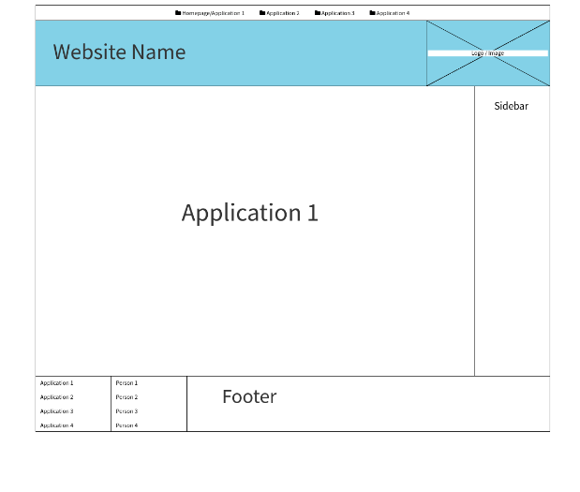

1. List of Applications
   1. Devin Treichel – Memory Game Application
   2. Joan Poon – Simple Painter Application
   3. Julie Hou – Calculator For Kids Application
   4. Elham Amouhadi – Alphabet Learning Flashcards
2. **Other Issues**
   1. Algorithm for application
   2. Data validation
   3. Check for syntax/logical errors

## information storage in the file (data format etc.)

## We don’t have information storage.

## Individual Details

Fill out Individual Details to turn in here.

**Each individual should also provide**

* **user interface for individual application**

SideBar:1. Click on the open button to open the side bar.

4 game button associate with 4 applications

* 1. (Devin Treichel – Memory Game Application
  2. Joan Poon – Simple Painter Application
  3. Julie Hou – Calculator For Kids Application
  4. Elham Amouhadi – Alphabet Learning Flashcards)

Calculator application: calculator, click the bottoms for “+”,”-”,” *”,”/”, “c”,” =” to get the answers

**functionality description and method of achieving functionality**

used switch case for the operator+,-,*./

add a click event to clear button.

**user scenarios for your application that you plan to meet**

a kid like to learn math.

Simple math like: +

-

*

/

When kids click 1 +1 the calculator will give the answers= 2

When kids click 1 -1 the calculator will give the answers= 0

When kids click 1 *1 the calculator will give the answers= 1

When kids click 1 /1 the calculator will give the answers= 1

If kids didn’t click on the number and click on something else trying to get the answer, the calculator will warn: You broke it!

Dominator can’t be 0. If kids use 0 as dominator. The calculator will broke and gone!

And they can click the reset button to bring the calculator back!